Mark Stevens | Course Management | July 26, 2020

Course Management Project

Starting a JSP, MySql, Hibernate, Persistence Project from scratch using eclipse



# Course Management Project

The Beginning

This project is based on the excellent book ***“Java EE 8 Development with Eclipse”***

The premise is to create a management app at a college that handles student registration, adding courses with teacher, subject, & credits. The basis is the excellent tutorials from Ramesh over at [www.javaguides.net](http://www.javaguides.net) along with the material from the book. My first attempt will be to create a CRUD application for the Courses.

Starting with the User Management Hibernate CRUD tutorial and making it **StudentManage. Notice the HibernateUtil file reference in the sessionFactory:**

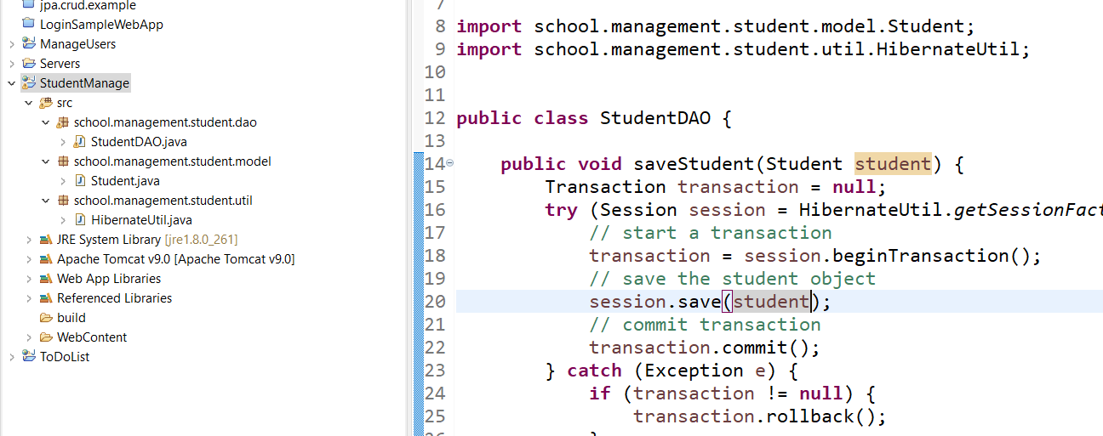



Figure : Hibernate Util file reference in the Session Factory

Here’s another thing to keep in mind about the Hibernate Utility, You could use the config file also according to [www.javaguides.com](http://www.javaguides.com):

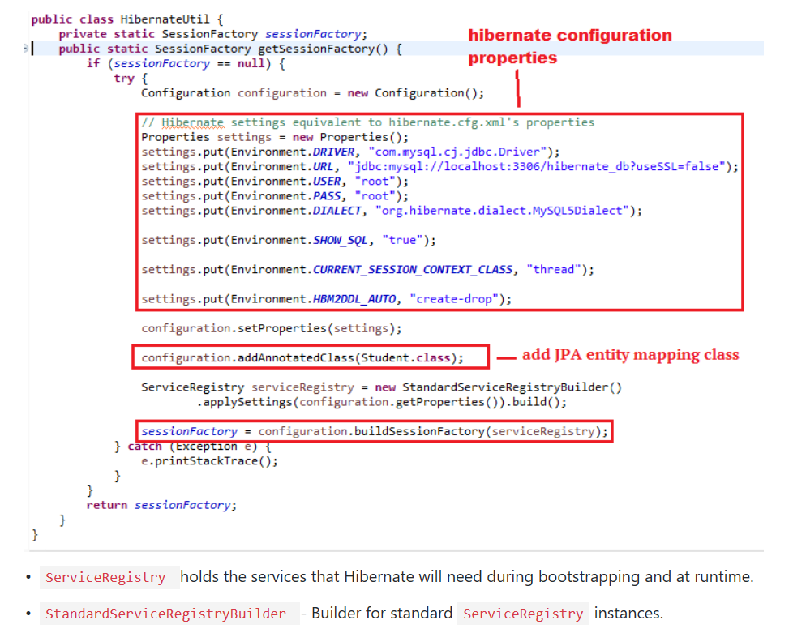

Figure : Hibernate Config file properties